CASEY SORRELLS
TASK 1

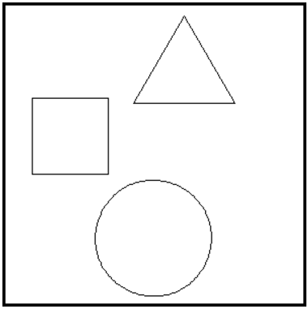
move -140
left 90

go circle
move 120
point 90
move 120

go square
point 90
move 70
right 90
move 100

go triangle
end

# circle
repeat 360
draw 2
right 2
next
return

# square
repeat 4
draw 75
right 90
next
return

# triangle
repeat 3
draw 100
left 120
next
return

